

**SG2002**

**Preliminary Datasheet**

Version: 1.0-alpha

Release date: 2023-12-15

© 2023 SOPHGO

Revision History

|  |  |  |  |
| --- | --- | --- | --- |
| Revision | Date | Description | |
| 1.0 | 2023/12/15 | Preliminary release 1.0-alpha |
|  |  |  |
|  |  |  |
|  |  |  |
|  |  |  |
|  |  |  |
|  |  |  |

Contents

Revision History 2

1 Product Overview 8

1.1 Overview 8

1.2 Architecture 9

1.2.1 Overview 9

1.2.2 Processor Core 9

1.2.3 TPU 10

1.2.4 Video Codec 10

1.2.5 Video Interface (SG2002) 10

1.2.6 ISP and Image Processing 11

1.2.7 CV Hardware Acceleration Engine 12

1.2.8 Audio Codec (SG2002) 12

1.2.9 Network Interface 12

1.2.10 Security System Module 12

1.2.11 Intelligent Secure Operating Environment 12

1.2.12 Peripheral Interface (SG2002) 13

1.2.13 External Memory Interface 13

1.2.14 SDK 14

1.2.15 Chip Physical Specifications 14

1.3 Boot and Upgrade Modes 14

1.3.1 Overview 14

1.3.2 Boot Mode and Corresponding Signal Latch Value Relationship 14

1.3.3 Image Burning Mode 15

1.3.4 Secure Boot 15

1.4 Address Space Mapping 16

2 Hardware Characteristics 20

2.1 Package and Pin Distribution 20

2.1.1 Package SG2002 20

2.1.2 Pin Distribution SG2002 21

2.2 Pin Information Description 21

2.3 Welding Process Suggestions 22

2.4 Moisture Sensitivity Parameters 23

2.4.1 Moisture Barrier Packaging for SOPHGO Products 23

2.5 Electrical Performance Parameters 26

2.5.1 Power Consumption Parameters 26

2.5.2 Temperature and Thermal Resistance Parameters (SG2002) 26

2.5.3 Destructive Voltage 27

2.5.4 Power Up/Down Sequence (SG2002) 27

2.5.5 Power Supply DC/AC Electrical Parameters 30

2.5.6 1.8V IO Electrical Parameters 32

2.5.7 18OD33 IO (VDDIO=1.8V) Electrical Parameters 32

2.5.8 18OD33 IO (VDDIO=3.0V) Electrical Parameters 33

2.5.9 Audio GPIO Electrical Parameters 35

2.5.10 ETH GPIO Electrical Parameters 35

2.5.11 MIPI Rx Electrical Parameters 35

2.5.12 Sub-LVDS Electrical Parameters 37

2.5.13 HiSPi Electrical Parameters 37

2.5.14 MIPI /LVDS Tx Electrical Parameters 38

2.5.15 SDIO Electrical Parameters 39

2.5.16 VI RAW/BT.601/BT.656/BT.1120 Electrical Parameters 39

2.5.17 BT.601/BT.656/8080 Electrical Parameters in VO (Video Out) 40

2.5.18 AUDIO CODEC Electrical Parameters 40

2.6 Timing 41

2.6.1 SPI NOR Timing 41

2.6.2 SPI NAND Timing 42

2.6.3 VI Timing 44

2.6.4 VO Timing 44

2.6.5 AIAO (I2S/PCM) Timing 46

2.6.6 I2C Timing 48

2.6.7 SPI Timing 49

2.6.8 MIPI Rx Timing 50

2.6.9 Sub-LVDS Timing 51

2.6.10 HiSPi Timing 52

2.6.11 MIPI Tx Timing 53

2.6.12 SDIO/MMC Timing 55

**List of Figures**

Figure 1‑1 SG2002 Architecture Diagram 9

Figure 2‑1 SG2002 Package Dimensions, Top View 20

Figure 2‑2 SG2002 Package External Dimensions, Bottom View 21

Figure 2‑3 SG2002 Pin Distribution 21

Figure 2-4 Lead-Free Reflow Soldering Process Curve 22

Figure 2‑5 Vacuum Drying Packaging Information 23

Figure 2‑6 Desiccant Packs, Humidity Indicator Card, Chip and Tray 24

Figure 2‑7 SPI NOR Timing Diagram 41

Figure 2‑8 SPI NAND Input Timing Diagram 42

Figure 2‑9 SPI NAND Output Timing Diagram 42

Figure 2‑10 VI Timing Diagram 44

Figure 2‑11 VO Timing Diagram 44

Figure 2‑12 BT.656 Timing Diagram 45

Figure 2‑13 BT.601 Timing Diagram 45

Figure 2‑14 BT.1120 Timing Diagram 45

Figure 2‑15 8080 Timing Diagram 46

Figure 2‑16 I2S & PCM Rx Timing Diagram 46

Figure 2‑17 I2S & PCM Tx Timing Diagram 47

Figure 2‑18 I2C Timing Diagram 48

Figure 2‑19 SPI Timing Diagram 49

Figure 2‑20 Timing Diagram of MIPI Rx Clock when 0.08Gbps ≤ Data Rate ≤ 1.5Gbps 50

Figure 2‑21 Sub-LVDS Clock Data Timing Diagram 51

Figure 2‑22 HiSPi Clock Data Timing Diagram 52

Figure 2‑23 MIPI TX Data-to-Clock Timing Diagram 53

Figure 2‑24 TX EYE Diagram Specification 54

Figure 2‑25 Transmitter Eye Diagram Validation Setup 54

Figure 2‑26 SDIO/MMC Single-Edge (SDR) Data Input/Output Timing Diagram 55

Figure 2‑27 SDIO/MMC Double Edge DDR50 Mode Data Input/Output Timing Diagram 56

Figure 2‑28 SDIO/MMC HS200 and SDR104 Mode Data Command Input/Output Timing Diagram 57

**List of Tables**

Table 2-1 Lead-Free Reflow Soldering Cover Parameters 22

Table 2-2 Humidity Classification and Floor Life 25

Table 2-3 Baking Temperature and Time Table 25

Table 2-4 Thermal Resistance Parameters for SG2002 26

Table 2-5 Temperature-Related Parameters 26

Table 2-6 Destructive Voltage Parameters (SG2002) 27

Table 2-7 The Power Supply Electrical Parameters of the SG2002 (Recommended Operating Conditions) 30

Table 2-8 1.8V IO Electrical Parameters 32

Table 2-9 18OD33 IO (VDDIO=1.8V) Electrical Parameters 32

Table 2-10 18OD33 IO (VDDIO=3.0V) Electrical Parameters 33

Table 2-11 Audio GPIO Electrical Parameters 35

Table 2-12 ETH GPIO Electrical Parameters 35

Table2*-*13MIPI D-PHY High Speed (MISH) Differential DC Electrical Parameters 36

Table 2-14 MIPI D-PHY High Speed (MIHS) Differential AC Electrical Parameters 36

Table 2-15 MIPI D-PHY Low Power (MILP) Differential DC Electrical Parameters 36

Table 2-16 MIPI D-PHY Low Power (MILP) Differential AC Electrical Parameters 37

Table 2-17 Sub-LVDS(SL) Differential DC Electrical Parameters 37

Table 2-18 Sub-LVDS(SL) Differential AC Electrical Parameters 37

Table 2-19 HiSPi Differential DC Electrical Parameters 37

Table 2-20 HiSPi Differential AC Electrical Parameters 38

Table 2-21 MIPI HS Transmitter DC Specifications 38

Table 2-22 MIPI HS Transmitter AC Specifications 38

Table 2-23 MIPI LP Transmitter DC Specifications 39

Table 2-24 MIPI LP Transmitter AC Specifications 39

Table 2-25 LVDS Transmitter DC/AC Specifications 39

Table 2-26 Audio CODEC Overall Indicator Table 40

Table 2-27 Audio DAC Electrical Parameters 40

Table 2-28 Audio ADC Electrical Parameters 40

Table 2-29 SPI_NOR Timing Parameter Table 41

Table 2-30 SPI NAND Input Timing 42

Table 2-31 SPI NAND Output Timing 43

Table 2-32 VI Timing Parameter Table 44

Table 2-33 VO Timing Parameter Table 45

Table 2-34 I2S/PCM Timing Parameter Table 47

Table 2-35 I2C Timing Parameter Table 48

Table 2-36 SPI Timing Parameter Table 49

Table 2-37 Timing Parameter of MIPI Rx at 0.08Gbps ≤ Data Rate ≤ 1.5Gbps 50

Table 2-38 Sub-LVDS Timing Parameter Table 51

Table 2-39 HiSPi Timing Parameters Table 52

Table 2-40 Data-Clock Timing Specifications for ≥ 0.08Gbps and ≤ 1 Gbps 53

Table 2-41 Data-Clock Timing Specifications for > 1Gbps and ≤ 1.5 Gbps 53

Table 2-42 Data-Clock Timing Specifications for > 1.5Gbps and ≤ 2.5 Gbps 53

Table 2-43 Transmitter Eye Diagram Specification 54

Table 2-44 SDIO/MMC Single Edge DS (Default Speed) Mode Timing Parameter Table 55

Table 2-45 SDIO/MMC Single Edge HS (High speed) Mode Timing Parameter Table 56

Table 2-46 SDIO/MMC Double Edge DDR50 Mode Timing Parameter Table 57

Table 2-47 SDIO/MMC HS200 and SDR104 Mode Output Parameters Table 58

Table 2-48 SDIO/MMC HS200 and SDR104 Mode Input Timing Parameter Table 58

# Product Overview

## Overview

SG2002 is a high-performance, low-power chip for edge intelligent surveillance IP cameras, smart cat-eye door locks, visual doorbells, home intelligence and many other product areas, integrating H.264 video compression codec, H.265 video compression encoder and ISP; support for HDR Wide Dynamics, 3D noise reduction, demisting, lens aberration correction, and other image enhancement and correction algorithms, providing customers with professional-grade video image quality. customers with professional-grade video image quality.

The chip also integrates a self-developed TPU that provides 1.0 TOPS of arithmetic power at 8-bit integer operations. The specially designed TPU scheduling engine efficiently provides extremely high bandwidth data streams to all tensor processor cores. A powerful deep learning model compiler and software SDK development kit are also provided for users. Mainstream deep learning frameworks, such as Caffe and Tensorflow, can be easily ported to its platform.

In addition, it also provides secure boot, secure update, secure encryption, etc. It provides a series of security solutions for users from development, mass production, and product application.

The chip integrates an 8-bit MCU subsystem, which can replace the general external MCU to achieve the purpose of saving BOM cost and power consumption.

## Architecture

### Overview



Figure 1‑ 1 SG2002 architecture diagram

### Processor Core

* Main Processor RISCV C906 @ 1.0Ghz
  + 32KB I-cache, 64KB D-Cache
  + Integrated Vector and floating-point unit (FPU)
* Main Processor ARM Cortex-A53 @ 1.0GHz
  + 32KB I-cache, 32KB D-Cache
  + 128KB L2 cache
  + Support for Neon and floating-point unit (FPU)
* Coprocessor RISCV C906 @ 700Mhz
  + Integrated floating-point unit (FPU)

The main processor RISCV C906 @ 1.0Ghz and the main processor ARM Cortex-A53 @ 1.0GHz can be switched via pin GPIO_RTX__EPHY_RTX (as shown below) with the switching logic:

Low-------ARM Cortex-A53 @ 1.0GHz

High------RISCV C906 @ 1.0Ghz

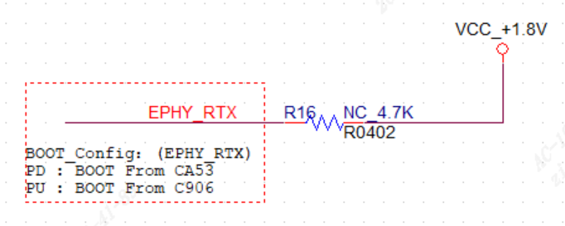

### TPU

* Built-in TPU, with ~1.0TOPS INT8
* Support for major neural network architectures: Caffe, Pytorch, TensorFlow (Lite), ONNX and MXNet
* It can realize Pedestrian Detection, Face Detection, Face recognition, Face anti-spoofing and other video structuring applications.

### Video Codec

* H.264 Baseline/Main/High profile
* H.265 Main profile
* H.264/H.265 both support I-frame and P-frame
* MJPEG/JPEG baseline
* H.264 codec maximum resolution: 2880×1620 (5M)
* H.265 encoding maximum resolution: 2880×1620 (5M)
* H.264 codec performance
  + 2880×1620@30fps+720×576@30fps
  + 1920×1080@30fps encoding + 1920×1080@30fps Decoding
* H.265 Encoding Performance
  + 2880×1620@30fps+720×576@30fps
* JPEG maximum codec performance
  + 2880×1620@30fps
* Supports multiple bit rate control modes such as CBR/VBR/FIXQP.
* Support Region of Interest (ROI) coding

### Video Interface (SG2002)

* Input
  + Supports two simultaneous video inputs (mipi 2L+1L)
  + Support MIPI, Sub-LVDS, HiSPI and other serial interfaces
  + Support 8/10/12 bit RGB Bayer video input
  + Support BT.656
  + Support AHD Multi-Mix BT format
  + Support SONY, OnSemi, OmniVision and other HD CMOS sensors
  + Provides a programmable frequency output for the sensor as a reference clock
  + Support a maximum width of 2880 and a maximum resolution of 5M (2688×1944, 2880×1620)
* Output
  + Support a wide range of serial and parallel display specifications
  + Support serial interfaces such as MIPI
  + Support BT656, BT601(8bit), BT1120, 8080 and other parallel interfaces
  + Support SPI output interface

### ISP and Image Processing

* + Support image or video rotation by 90, 180, or 270 degrees
  + Support horizontal (Flip) or vertical (Mirror) flipping of image or video
  + Support overlaying two layers of OSD (On-Screen Display) on the video
  + Support video scaling down to 1/32 or up to 32 times
  + Support 3A algorithm: automatic exposure (AE), automatic white balance (AWB), and automatic autofocus (AF)
  + Support fixed-mode noise reduction and bad pixel correction
  + Support correction of lens shading, distortion, and purple fringing
  + Support direction-adaptive demosaic algorithm that selects the best demosaic algorithm based on the image orientation
  + Support Gamma correction, dynamic contrast enhancement, and color management algorithms
  + Support regional adaptive defogging
  + Support Bayer denoising, 3D denoising, detail enhancement, and sharpening enhancement
  + Support local Tone mapping
  + Support sensor with wide dynamic range and 2-frame wide dynamic range
  + Support two-axis digital image stabilization
  + Support lens distortion correction
  + Provide PC-side ISP tuning tools

### CV Hardware Acceleration Engine

* Hardware/software mixed mode support for some OpenCV libraries
* Hardware/Software Mixed Mode support for some IVE libraries

### Audio Codec (SG2002)

* Integrated Audio CODEC, supports 16-bit audio/voice input and output
* Integrated mono microphone input
* Integrated mono output. (Requires external amplifier to drive speakers)
* An internal microphone is integrated for direct connection to the output channel, making it easy to implement AEC
* Software audio codec protocols (G.711, G.726, ADPCM)
* The software supports Audio 3A (AEC, ANR, AGC) functions

### Network Interface

* The Ethernet module provides one Ethernet MAC for receiving and sending network data
* Ethernet MAC with built-in 10/100Mbps Fast Ethernet Transceiver can work in 10/100Mbps full duplex or half duplex mode

### Security System Module

* Hardware implementation of multiple encryption and decryption algorithms such as AES/DES/SM4
* Hardware implementation of HASH (SHA1/SHA256) hash algorithm
* Hardware implementation of a random number generator
* Internally integrated 2Kbit eFuse logical space

### Intelligent Secure Operating Environment

* Support the establishment of a trust chain: provide the basis for a secure environment, which is the foundation of a trusted environment, such as hardware security settings, root of trust, etc.
* Support secure boot, provides secure hardware and software protection functions
* Support data encryption security: data encryption program, computing core encryption
* Support software and firmware validation process: confirms software trustworthiness and integrity, including boot and load the signature verification program
* Support secure storage and transmission: protects external data storage and exchange
* Support security updates

### Peripheral Interface (SG2002)

* Integrated POR, Power sequence
* 4 single-ended ADCs (3 no die domain)
* 6 I2C (1 no die domain)
* 3 SPI
* 5 groups of UART (1 no die domain)
* 4 groups (15 channels) PWM
* 2 SDIO interfaces

One supports 3V to connect to SD 3.0 Card (supporting a maximum capacity

of SDXC 2TB, supported speed is UHS-I)

One supports 1.8V/3.0V to connect other SDIO 3.0 devices. (Supported speed

is UHS-I)

* 66 GPIO Interface (14 no die domain)
* Integrated keyscan and Wiegand
* Integrated MAC PHY supports 10/100Mbps full-duplex or half-duplex mode.
* One USB Host / device interface

### External Memory Interface

* Built-in DRAM
  + SG2002 DDR3 16bitx1, maximum rate up to 1866Mbps, capacity 2Gbit (256MB)
* SPI NOR flash interface (1.8V/3.0V)
  + Support 1, 2, 4-wire modes
  + Maximum support for 256MByte
* SPI Nand flash interface (1.8V/3.0V)
  + Support 1KB/2KB/4KB page (corresponding maximum capacity 16GB/32GB/64GB)
  + Uses the built-in ECC module of the device
* eMMC 4.5 interface (1.8V/3.0V) SD0 EMMC co-power supply. Because of SD card default 3V, it is not suitable to connect 1.8V eMMC with SD card
  + 4-bit interface
  + Support HS200
  + Maximum Supported Capacity 2TB

### SDK

* Linux-5.10-based SDK

### Chip Physical Specifications

* Power Consumption
  + 1080P + Video encode + AI: ~ 500mW
  + Other Scenarios: TBD
* Operating voltage
  + Core voltage: 0.9V
  + IO voltage: 1.8V and 3.0V
  + The DDR voltage is shown in the table below.
    - SG2002 = 1.35V
* Package
  + Using QFN package, the package size is 9mm×9mm×0.9mm. The pin pitch is 0.35mm, and the total number of pins is 88

## Boot and Upgrade Modes

### Overview

The chip is booted by the built-in ROM (BOOTROM). When the chip is reset, it detects whether there is a weak pull-up or weak pull-down on two pins (EMMC_DAT3, EMMC_DAT0) to determine the type of memory device currently in use.

Secure boot chips are signed during boot-up and chip upgrades to ensure that the software being executed or upgraded is secure.

### Boot Mode and Corresponding Signal Latch Value Relationship

* Support booting from SPI Nor Flash (EMMC_DAT3 pull down, EMMC_DAT0 pull up)
* Support booting from SPI Nand Flash (EMMC_DAT3 pull down, EMMC_DAT0 pull down)
* Support booting from eMMC (EMMC_DAT3 pull up, EMMC_DAT0 pull up)

Notes: SG2002 does not support eMMC because SD0 and eMMC domain share IO power. Since the SD card defaults to 3.0V and eMMC is mostly 1.8V, it basically does not support eMMC unless SD0 does not connect to the SD card.

### Image Burning Mode

* Supports burning image through SD card
* Supports burning image through USB device mode
* If the image already exists in flash, software supports upgrading through the network

### Secure Boot

* Supports secure boot and upgrade
* AES/DES/SM4 hardware encryption and decryption
* SHA/TRNG/Secure eFuse security hardware

## Address Space Mapping

|  |  |  |  |
| --- | --- | --- | --- |
| Starting Address [31:0] | End Address [31:0] | Space Function | Space Size (Byte) |
| 0x01000000 | 0x017FFFFF | reserve | 8M |
| 0x01800000 | 0x018FFFFF | reserve |  |
| 0x01900000 | 0x01900FFF | ap_mailbox | 4K |
| 0x01901000 | 0x01901FFF | ap_system_ctrl | 4K |
| 0x01902000 | 0x019EFFFF | reserve |  |
| 0x01F00000 | 0x01F0FFFF | reserve | 64K |
| 0x01F10000 | 0x01FFFFFF | reserve |  |
| 0x02000000 | 0x02FFFFFF | reserve | 64K |
| 0x03000000 | 0x03000FFF | TOP_MISC control register | 4K |
| 0x03001000 | 0x03001FFF | PINMUX control register | 4K |
| 0x03002000 | 0x03002FFF | CLKGEN/PLL control register | 4K |
| 0x03003000 | 0x03003FFF | RSTGEN control register | 4K |
| 0x03004000 | 0x03005FFF | reserve |  |
| 0x03006000 | 0x03006FFF | reserve | 4K |
| 0x03007000 | 0x03008FFF | reserve |  |
| 0x03009000 | 0x03009FFF | reserve | 4K |
| 0x0300A000 | 0x0300AFFF | reserve | 4K |
| 0x0300B000 | 0x0300FFFF | reserve |  |
| 0x03010000 | 0x03010FFF | WATCH DOG0 control register | 4K |
| 0x03011000 | 0x03011FFF | WATCH DOG1 control register | 4K |
| 0x03012000 | 0x03012FFF | WATCH DOG2 control register | 4K |
| 0x03020000 | 0x03020FFF | GPIO0 control register | 4K |
| 0x03021000 | 0x03021FFF | GPIO1 control register | 4K |
| 0x03022000 | 0x03022FFF | GPIO2 control register | 4K |
| 0x03023000 | 0x03023FFF | GPIO3 control register | 4K |
| 0x03024000 | 0x0302FFFF | reserve |  |
| 0x03030000 | 0x03030FFF | WGN0 control register | 4K |
| 0x03031000 | 0x03031FFF | WGN1 control register | 4K |
| 0x03032000 | 0x03032FFF | WGN2 control register | 4K |
| 0x03033000 | 0x0303FFFF | reserve |  |
| 0x03040000 | 0x0304FFFF | KEYSCAN control register | 64K |
| 0x03050000 | 0x0305FFFF | EFUSE control register | 64K |
| 0x03060000 | 0x03060FFF | PWM0 control register | 4K |
| 0x03061000 | 0x03061FFF | PWM1 control register | 4K |
| 0x03062000 | 0x03062FFF | PWM2 control register | 4K |
| 0x03063000 | 0x03063FFF | PWM3 control register | 4K |
| 0x03064000 | 0x0309FFFF | reserve |  |
| 0x030A0000 | 0x030AFFFF | TIMER control register | 64K |
| 0x030C0000 | 0x030CFFFF | reserve |  |
| 0x030D0000 | 0x030D0FFF | reserve | 4K |
| 0x030D1000 | 0x030D1FFF | reserve | 4K |
| 0x030D2000 | 0x030D2FFF | reserve | 4K |
| 0x030D3000 | 0x030DFFFF | reserve |  |
| 0x030E0000 | 0x030EFFFF | TEMPSEN control register | 64K |
| 0x030F0000 | 0x030FFFFF | SARADC control register | 64K |
| 0x04000000 | 0x0400FFFF | I2C0 control register | 64K |
| 0x04010000 | 0x0401FFFF | I2C1 control register | 64K |
| 0x04020000 | 0x0402FFFF | I2C2 control register | 64K |
| 0x04030000 | 0x0403FFFF | I2C3 control register | 64K |
| 0x04040000 | 0x0404FFFF | I2C4 control register | 64K |
| 0x04050000 | 0x0405FFFF | reserve |  |
| 0x04060000 | 0x0406FFFF | SPI_NAND control register | 64K |
| 0x04070000 | 0x0407FFFF | ETH0 control register |  |
| 0x04080000 | 0x040FFFFF | reserve |  |
| 0x04100000 | 0x04107FFF | I2S0 control register | 64K |
| 0x04108000 | 0x0410FFFF | I2S Global control register | 64K |
| 0x04110000 | 0x0411FFFF | I2S1 control register | 64K |
| 0x04120000 | 0x0412FFFF | I2S2 control register | 64K |
| 0x04130000 | 0x0413FFFF | I2S3 control register | 64K |
| 0x04140000 | 0x0414FFFF | UART0 control register | 64K |
| 0x04150000 | 0x0415FFFF | UART1 control register | 64K |
| 0x04160000 | 0x0416FFFF | UART2 control register | 64K |
| 0x04170000 | 0x0417FFFF | UART3 control register | 64K |
| 0x04180000 | 0x0418FFFF | SPI0 control register | 64K |
| 0x04190000 | 0x0419FFFF | SPI1 control register | 64K |
| 0x041A0000 | 0x041AFFFF | SPI2 control register | 64K |
| 0x041B0000 | 0x041BFFFF | SPI3 control register | 64K |
| 0x041C0000 | 0x041CFFFF | UART4 control register | 64K |
| 0x041D0000 | 0x041DFFFF | AUDSRC control register | 64K |
| 0x041E0000 | 0x042FFFFF | reserve |  |
| 0x04300000 | 0x0430FFFF | eMMC control register | 64K |
| 0x04310000 | 0x0431FFFF | SD0 control register | 64K |
| 0x04320000 | 0x0432FFFF | SD1 control register |  |
| 0x04330000 | 0x0433FFFF | DMA control register | 64K |
| 0x04340000 | 0x0434FFFF | USB control register | 64K |
| 0x04350000 | 0x043FFFFF | reserve |  |
| 0x04400000 | 0x0441FFFF | ROM memory space | 128K |
| 0x04420000 | 0x04FFFFFF | reserve |  |
| 0x05000000 | 0x05000FFF | reserve | 4KB |
| 0x05020000 | 0x05020FFF | RTCSYS_Timer control register | 4KB |
| 0x05021000 | 0x05021FFF | RTCSYS_GPIO control register | 4KB |
| 0x05022000 | 0x05022FFF | RTCSYS_UART control register | 4KB |
| 0x05023000 | 0x05023FFF | RTCSYS_INTR control register | 4KB |
| 0x05024000 | 0x05024FFF | RTCSYS_MBOX control register | 4KB |
| 0x05025000 | 0x05025FFF | RTCSYS_CTRL control register | 4KB |
| 0x05026000 | 0x05026FFF | RTCSYS_CORE | 4KB |
| 0x05027000 | 0x05027FFF | RTCSYS_IO control register | 4KB |
| 0x05028000 | 0x05028FFF | RTCSYS_OSC control register | 4KB |
| 0x05029000 | 0x05029FFF | reserve | 4KB |
| 0x0502A000 | 0x0502AFFF | RTCSYS_32kless control register | 4KB |
| 0x0502B000 | 0x0502BFFF | RTCSYS_I2C control register | 4KB |
| 0x0502C000 | 0x0502CFFF | RTCSYS_SAR control register | 4KB |
| 0x0502D000 | 0x0502DFFF | RTCSYS_WDT control register | 4KB |
| 0x0502E000 | 0x0502EFFF | RTCSYS_IRRX control register | 4KB |
| 0x05200000 | 0x053FFFFF | RTCSYS_SRAM | 8KB |
| 0x05400000 | 0x057FFFFF | RTCSYS_SPINOR | 4MB |
| 0x08000000 | 0x08001FFF | reserve | 8K |
| 0x08004000 | 0x08005FFF | DDR Controller control register | 8K |
| 0x08006000 | 0x08007FFF | reserve | 8K |
| 0x08008000 | 0x08009FFF | DDR AXI Monitor control register | 8K |
| 0x0800A000 | 0x0800BFFF | DDR Global control register | 8K |
| 0x08010000 | 0x08011FFF | reserve | 8K |
| 0x08012000 | 0x08013FFF | reserve | 8K |
| 0x08014000 | 0x09FFFFFF | reserve |  |
| 0x0A000000 | 0x0A07FFFF | ISP control register | 512K |
| 0x0A080000 | 0x0A0803FF | sc_top control register | 1K |
| 0x0A080400 | 0x0A080BFF | reserve | 2K |
| 0x0A080C00 | 0x0A080CFF | osd enc control register | 256B |
| 0x0A080D00 | 0x0A080FFF | reserve | 768B |
| 0x0A081000 | 0x0A081FFF | reserve | 4K |
| 0x0A082000 | 0x0A082FFF | img_v control register | 4K |
| 0x0A083000 | 0x0A083FFF | img_d control register | 4K |
| 0x0A084000 | 0x0A084FFF | sc_d control register | 4K |
| 0x0A085000 | 0x0A085FFF | sc_v1 control register | 4K |
| 0x0A086000 | 0x0A086FFF | sc_v2 control register | 4K |
| 0x0A087000 | 0x0A087FFF | sc_v3 control register | 4K |
| 0x0A088000 | 0x0A088FFF | DISP control register | 4K |
| 0x0A089000 | 0x0A089FFF | reserve | 4K |
| 0x0A08A000 | 0x0A08AFFF | dsi_mac control register | 4K |
| 0x0A08B000 | 0x0A08BFFF | cmdq control register | 4K |
| 0x0A08C000 | 0x0A08CFFF | reserve | 4K |
| 0x0A08D000 | 0x0A08DFFF | reserve | 4K |
| 0x0A08E000 | 0x0A09FFFF | reserve | 72K |
| 0x0A0A0000 | 0x0A0AFFFF | IVE control register | 64K |
| 0x0A0A0000 | 0x0A0BFFFF | reserve | 64K |
| 0x0A0C0000 | 0x0A0C1FFF | ldc control register | 8K |
| 0x0A0C2000 | 0x0A0C3FFF | VI0/MIPI_RX0 control register | 8K |
| 0x0A0C4000 | 0x0A0C5FFF | VI1/MIPI_RX1 control register | 8K |
| 0x0A0C6000 | 0x0A0C7FFF | VI2/MIPI_RX2 control register | 8K |
| 0x0A0C8000 | 0x0A0C9FFF | VIPSYS control register | 8K |
| 0x0A0CA000 | 0x0A0CFFFF | reserve | 24K |
| 0x0A0D0000 | 0x0A0D0FFF | CSI_PHY control register | 4K |
| 0x0A0D1000 | 0x0A0D1FFF | DSI_PHY control register | 4K |
| 0x0A0D2000 | 0x0AFFFFFF | reserve |  |
| 0x0B000000 | 0x0B00FFFF | JPEG codec control register | 64K |
| 0x0B010000 | 0x0B01FFFF | H.264 codec control register | 64K |
| 0x0B020000 | 0x0B02FFFF | H.265 codec control register | 64K |
| 0x0B030000 | 0x0BFFFFFF | reserve |  |
| 0x0C000000 | 0x0FFFFFFFF | reserve |  |
| 0x10000000 | 0x1FFFFFFFF | SPI_NOR memory space | 256M |
| 0x30000000 | 0x7FFFFFFFF | reserve |  |
| 0x80000000 | 0xFFFFFFFF | DDR memory space | 2G |

*Read and write operations to reserved address space may produce unintended results.

# Hardware Characteristics

## Package and Pin Distribution

### Package SG2002

SG2002 uses QFN package with dimensions of 9mm×9mm×0.9mm. The pin pitch is 0.35mm. The total number of pins is 88. Please refer to the figure below for more detailed package dimensions.

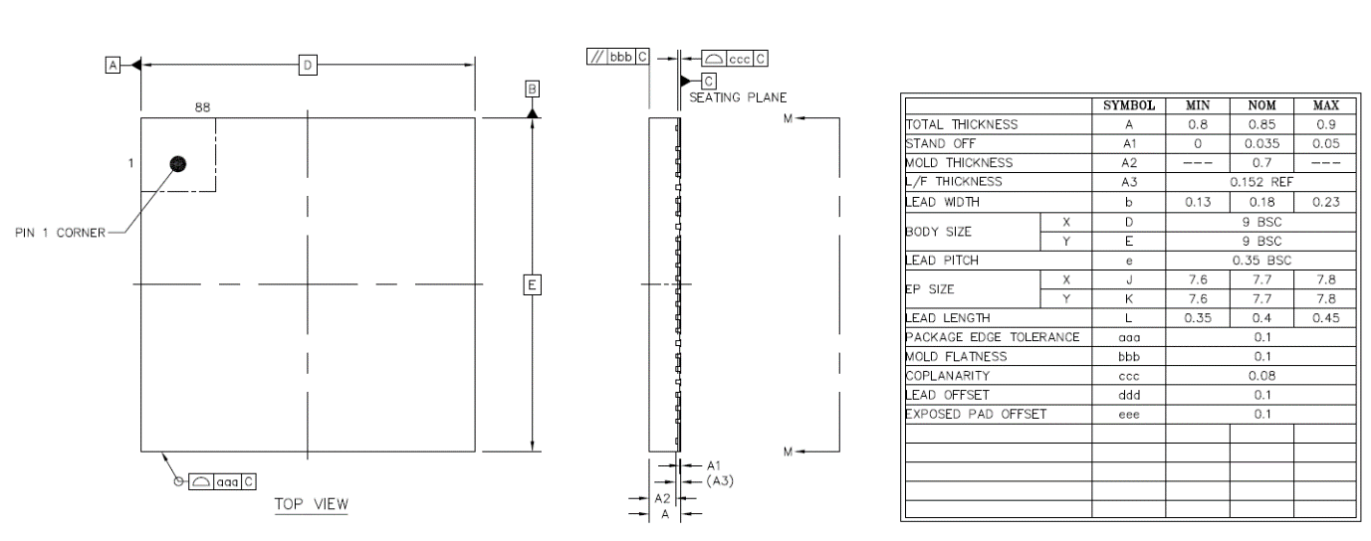

Figure 2‑1 SG2002 package dimensions, top view

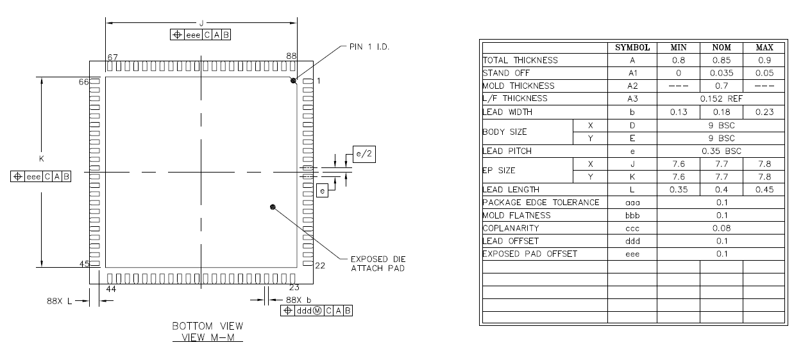

Figure 2‑2 SG2002 Package external dimensions, bottom view

### Pin Distribution SG2002

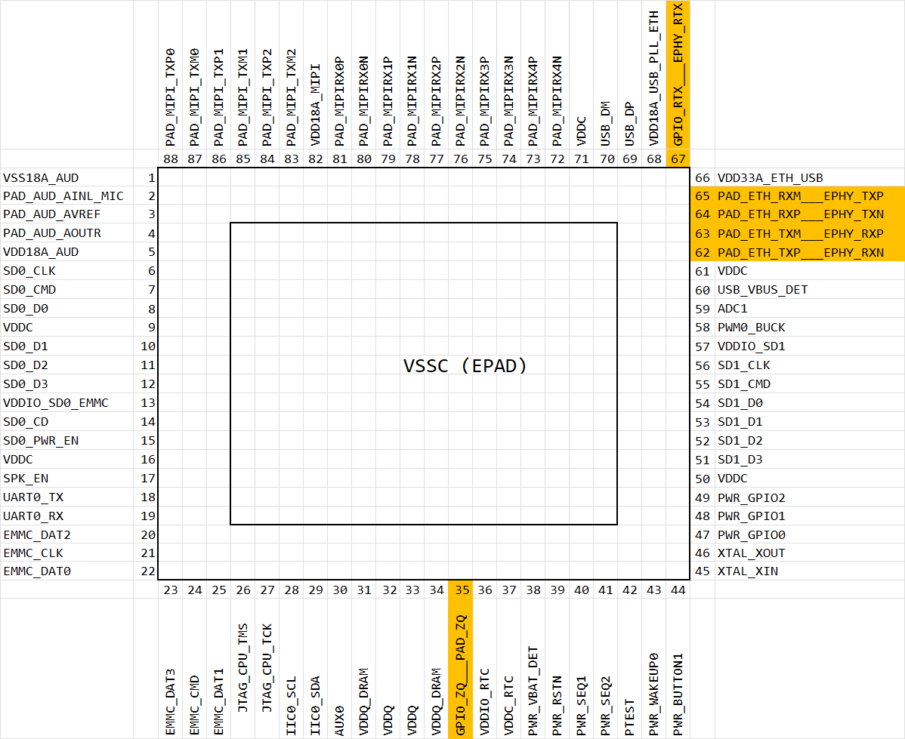

Figure 2‑3 SG2002 pin distribution

## Pin Information Description

Please refer to SG2002_PINOUT_CN.xlsx

## Welding Process Suggestions

Please refer to Figure 2-4 for the lead-free reflow soldering process curve.

SG2002 Please refer to Pure Sn.

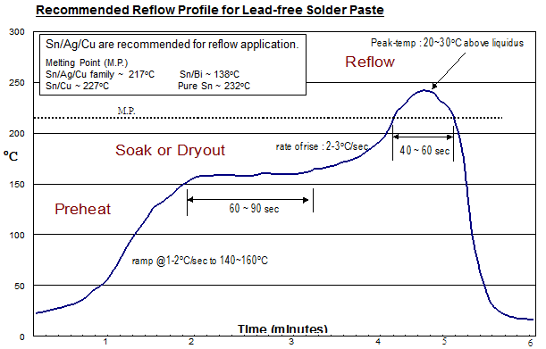

Figure 2-4 Lead-free reflow soldering process curve

Please refer to Table 2-1 for the parameters of lead-free reflow soldering process.

The following parameters are only recommended values for reference. Clients need to make relative adjustments according to the actual production conditions.

Table 2-1 Lead-free reflow soldering cover parameters

|  |  |  |  |  |
| --- | --- | --- | --- | --- |
| Area | Time | Heating Rate | Peak Temperature | Cooling Rate |
| preheat zone (40~150oC) | 60~120sec | 1~2oC/sec |  |  |
| Soak zone (150~200oC) | 60~90sec | < 1oC/sec |  |  |
| reflow zone   (>melting point 20~30oC) | 40~60sec | 2~3oC/sec | Sn/Ag/Cu 237~247oC  Sn/Cu 247~257oC  Pure Sn 252~262oC |  |
| cooling Zone  (Tmax~Tamb) |  |  |  | 1~4oC/sec |

Due to environmental protection considerations, the parameters for leaded reflow soldering are not provided currently.

## Moisture Sensitivity Parameters

### Moisture Barrier Packaging for SOPHGO Products

This section establishes the principles for the storage and use of chips (moisture sensitive products) during welding. The relevant terms are as follows:

* Floor life: refers to the maximum allowable time between opening the moisture barrier packaging and reflow, in an environment with temperature < 30°C/60% RH.
* Shelf life: refers to the normal storage time after the moisture barrier packaging has been sealed.

#### Packaging Information

The moisture-proof vacuum bag containing (1) chip and tray. (2) desiccant Pack (3) Humidity Indicator Card (HIC)

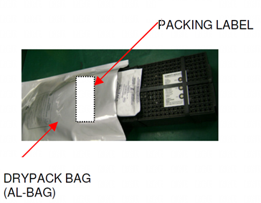

Figure 2‑5 Vacuum drying packaging information

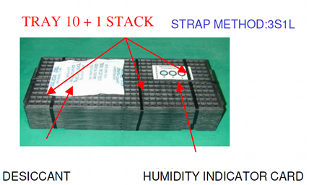

Figure 2‑6 Desiccant packs, humidity indicator card, chip and tray

#### Moisture-Sensitive Product Incoming Inspection

After opening the vacuum moisture-proof bag before SMT, inspect the humidity indicator card. There are many different styles of humidity indicator cards, but if it shows that it has been exposed to moisture, it must be baked before SMT use. The relevant time and temperature parameters for baking are shown in Table 2-3.

If re-packaging after opening, and it has not been exposed for more than 2 hours in an environment of <30°C/60% RH, it can be vacuum dried and packaged by only replacing the drying bag. If it exceeds 2 hours, it is recommended to re-bake, replace the drying bag, and then reseal the package.

#### Storage and Use (Refer to JEDEC J-STD-033)

* Shelf life:  
  The sealed vacuum moisture-proof bag can be stored for at least 12 months in an environment of 40°C/90% RH.
* Floor life:  
  Before SMT, if the humidity card indicates that the components have not been exposed to moisture after opening in an environment of 30°C/60% RH, it can be used directly without baking. The time for Level 3 (the floor life classification of this chip is Level 3) is shown in Table 2-2.

Table 2-2 Humidity classification and floor life

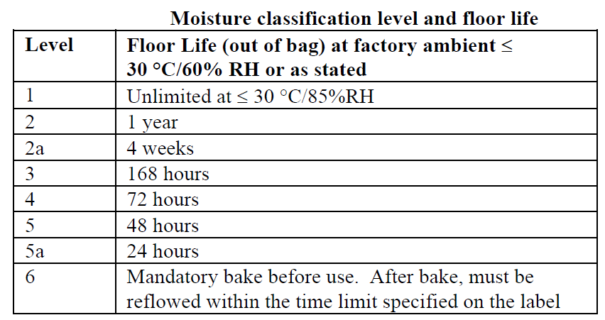

#### Rebaking

If found to have been exposed to moisture after opening, before SMT or before being resealed in vacuum packaging, they should be baked first. Baking temperature and time can be referred to in Table 2-3 .

After baking, shelf life can be recalculated after being sealed in moisture-proof packaging.

If not sealed in moisture-proof packaging after baking, the storage time should refer to the floor life.

Table 2-3 Baking temperature and time table

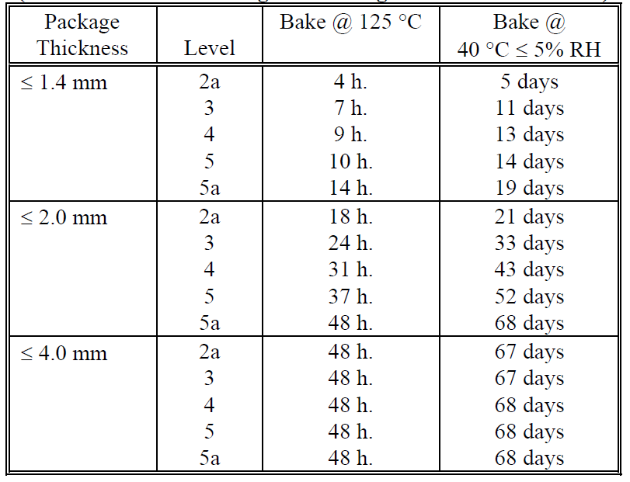

## Electrical Performance Parameters

### Power Consumption Parameters

Typical scenario: 1080P + Video Encode + AI ~500mW

Other scenarios: TBD

### Temperature and Thermal Resistance Parameters (SG2002)

Thermal resistance values ThetaJA, JB, JC of the chip. The results of the actual test conducted on the JEDEC 2s2p PCB are shown in Table 2-4.

Table 2-4 Thermal resistance parameters for SG2002

|  |  |  |  |  |  |  |  |
| --- | --- | --- | --- | --- | --- | --- | --- |
| PCB Condition | Package Size(mm) | Theta JA (C/W) | | | Psi Jt  (C/W) | Theta JC  (C/W) | Theta JB (C/W) |
| **0** m/s | **1** m/s | **2** m/s |
| JEDEC 2s2p PCB | 9×9 | 20.3 | 15.9 | 14.8 | 0.17 | 6.9 | 5.32 |

The temperature-related parameters of the chip are shown in Table 2-5.

Table 2-5 Temperature-related parameters

|  |  |  |  |
| --- | --- | --- | --- |
|  | Min | Max | Note |
| Working environment temperature Tamb | -30oC | 70oC | 1 |
| Recommended value for the junction temperature (Tjunc) of chip | -30oC | 85oC ~ 105oC | 2 |
| Destructive junction temperature | -40oC | +125oC | 3, 4 |

1. The maximum operating temperature in the working environment depends on the power consumption and heat dissipation conditions of the scenario, without violating the premise of junction temperature.
2. The recommended range of junction temperature is mainly considered to avoid thermal runaway caused by poor heat dissipation conditions at high temperatures, which may lead to uncontrolled temperature entering the destructive junction temperature range and damaging the chip. In addition, long-term operation at high temperatures may slightly accelerate chip aging and reduce its service life.
3. The DRAM used guarantees a junction temperature of only -40°C to 115°C. Content inside the DRAM cannot be guaranteed to remain intact beyond this range.
4. When the chip operates at the destructive junction temperature, it may cause irreversible physical damage to the chip.

### Destructive Voltage

The destructive voltage parameters are shown in Table 2-6 . When working above destructive voltage, it may cause irreversible physical damage.

Table 2-6 Destructive voltage parameters (SG2002)

|  |  |  |  |  |
| --- | --- | --- | --- | --- |
| Parameter |  | Max | Unit | |
| VDDC | Core power | 1.05V | V |
| VDDC_RTC | Core power for RTC domain (comes with LDO) |
| VDD18A_AUD | Analog power for Audio ADC/DAC | 1.98 | V |
| vdd18a_usb_pll_eth | Analog power for USB, PLL, ETH, eFuse | 1.98 | V |
| VDD18A_MIPI | Analog power for MIPI | 1.98 | V |
| VDD33A_ETH_USB | Analog power for Ethernet PHY, USB PHY | 3.465 | V |
| VDDIO_SD0_EMMC | IO power for EMMC & SD0 domain | 3.465 | V |
| VDDIO_SD1 | IO power for SD1 domain | 3.465 | V |
| VDDIO_RTC | IO power for RTC domain (backup power) | 1.98 | V |
| VDDQ  VDDQ_DRAM | IO & DRAM Power for DDR2/DDR3L/DDR3 | 1.65 | V |

### Power Up/Down Sequence (SG2002)

In principle, chips can be divided into the following groups. The same group of power domains can be powered up/down at the same time. For different groups, the power up/down time is separated according to the following conditions.

* Always on domain
  + VDDIO_RTC (1.8V)
  + VDDC_RTC (0.9V) (built-in LDO)
  + VDDIO_SD1
* Core power domain
  + VDDC
* 1.8V IO domain
  + VDD18A_AUD (analog)
  + VDD18A_USB_PLL_ETH (analog)
  + VDD18A_MIPI (analog)
* 18OD33 IO domain (1.8V domain / 3V domain depending on voltage)
  + VDDIO_SD1 (also no die domain)
* 3V domain
  + VDDIO_SD0_EMMC
  + VDD33A_ETH__USB
* DDR IO & DRAM domain
  + VDDQ
  + VDDQ_DRAM

In principle, 0.9V power domain and 1.8V power domain can be powered up at the same time, or power-up the 0.9V power domain prior to 1.8V power domain. **However, the 3V power domain must be powered on after the establishment of 1.8V power domain. Violations may cause irreversible damage to the chip.** Thepower down sequence is the reverse of the power up sequence.



Possible risky power-up and power-down behaviors include:

1. During power-up, if VDD3 > 2V while VDD18 has not reached 1.8V-10%, it may damage the 3V circuit.
2. During power-down, if VDD3 < 2V while VDD18 has already dropped below 1.8V-10%.
3. During power-up, if VDD18 > 0.7V while VDD09 is still below 0.5V, it may cause eFuse misoperation.
4. During power-down, if VDD09 < 0.5V while VDD18 is still > 0.7V, it may also cause eFuse misoperation.

The chip provides two pins, PWR_SEQ1 and PWR_SEQ2, to co-control the power supply (VDDIO_RTC domain) switch. SEQ1 is preset to 0.9V and 1.8V, while SEQ2 controls 3V. Some plug-in systems may use RC to determine the switch for both 0.9V and 1.8V, but it is important that the chip's 3V still needs to be controlled by SEQ2 to prevent damage.

SEQ1 -> SEQ2 at power-up

SEQ2 -> SEQ1 on power off

PWR_VBAT_DET is used to detect the status of the main power supply. If the voltage is low, the software will receive an interrupt first (such as stopping writing flash to prevent damage to the file system). If the voltage continues to drop, the RTC module will actively start the power-down program. PWR_VBAT_DET also needs to be logic high to start up.



In practice. The following four conditions can be subdivided. The recommendations are as follows.

|  |  |  |  |
| --- | --- | --- | --- |
| Power | Control | Plug-in Applications (1)  Ext RTC/no RTC | Plug-in Applications (2)  32Kless |
| Main 0.9V | Always on | VDDC | VDDC |
| Main 1.8V | Always on | VDD18A_AUD  vdd18a_usb_pll_eth  VDD18A_MIPI  VDDIO_SD1  VDDIO_RTC | VDD18A_AUD  vdd18a_usb_pll_eth  VDD18A_MIPI |
| Main 3.0V | SEQ2 | VDD33A_ETH_USB  VDDIO_SD0_EMMC  VDDIO_SD1 | VDD33A_ETH_USB  VDDIO_SD0_EMMC |
| Main VDDQ | always on | VDDQ  VDDQ_DRAM | VDDQ  VDDQ_DRAM |
| VDDBACKUP | Coin Batt | For external RTC |  |
| V18RTC (low iddq LDO) | Always on, from Coin batt | No need | VDDIO_RTC  VDDIO_SD1 |

|  |  |  |  |
| --- | --- | --- | --- |
| Power | Control | Battery Applications (3)  Ext RTC/no RTC | Battery Applications (4)  32Kless |
| Main 0.9V | SEQ1 | VDDC | VDDC |
| Main 1.8V | SEQ1 | VDD18A_AUD  vdd18a_usb_pll_eth  VDD18A_MIPI | VDD18A_AUD  vdd18a_usb_pll_eth  VDD18A_MIPI |
| Main 3.0V | SEQ2 | VDD33A_ETH_USB  VDDIO_SD0_EMMC | VDD33A_ETH_USB  VDDIO_SD0_EMMC |
| Main VDDQ | SEQ2 or 3 | VDDQ  VDDQ_DRAM | VDDQ  VDDQ_DRAM |
| VDDBACKUP | Coin Batt | For external RTC |  |
| V18RTC (low iddq LDO) | Always on, from Coin batt | No need | VDDIO_RTC |
| VAO18 | from Main batt | WIFI  other AO device  VDDIO_RTC  VDDIO_SD1 | WIFI  other AO device  VDDIO_SD1 |
| VAO33 | from Main batt | WIFI  other AO device | WIFI  other AO device |

### Power Supply DC/AC Electrical Parameters

Table 2-7 The power supply electrical parameters of the SG2002 (Recommended OPERATING conditions)

|  |  |  |  |  |  |
| --- | --- | --- | --- | --- | --- |
| Parameter |  | Min | Typ | Max | Unit |
| VDDC | Core power | 0.81 | 0.9 | 0.99 | V |
| VDDC_RTC | Core power for RTC domain (Internal LDO, Cap only) | 0.81 | 0.9 | 0.99 | V |
|  |  |  |  |  |  |
| VDD18A_AUD | Analog power for Audio ADC/DAC | 1.62 | 1.8 | 1.98 | V |
| vdd18a_usb_pll_eth | Analog power for Ethernet PHY, USB PHY, PLL | 1.62 | 1.8 | 1.98 | V |
| VDD18A_MIPI | Analog power for MIPI | 1.62 | 1.8 | 1.98 | V |
|  |  |  |  |  |  |
| VDD33A_ETH_USB | Analog power for Ethernet PHY, USB PHY | 2.97 | 3.3 | 3.465 | V |
|  |  |  |  |  | V |
| VDDIO_SD0_EMMC | IO power for SD0 & EMMC domain | 1.71  2.85 | 1.8  3.0/3.3 | 1.89  3.15/3.465 | V |
| VDDIO_SD1 | IO power for SD1 domain | 1.71  2.85 | 1.8  3.0/3.3 | 1.89  3.465 | V |
|  |  |  |  |  |  |
| VDDIO_RTC | IO power for RTC domain IO & LDO | 1.3V | 1.8 | +10% | V |
|  |  |  |  |  |  |
| VDDQ  VDDQ_DRAM | IO & DRAM Power for DDR3L   IO & DRAM Power for DDR3  IO & DRAM Power for DDR2 | 1.283  1.425  1.425 | 1.35  1.50  1.50 | 1.417  1.575  1.575 | V |
|  |  |  |  |  |  |
| Tjunc | Junction Temperature (Max reduce from 125C due to DRAM) | -40 | 25 | 115  (note) | oC |
|  |  |  |  |  |  |

Note: The operating junction temperature of the DRAM used is guaranteed to be only between -40°C to 115°C. Contents inside the DRAM cannot be guaranteed to be intact beyond this temperature range.

### 1.8V IO Electrical Parameters

For domain (VDDIO18_0, VDDIO18_1, VDDIO18_RM0, VDDIO_RTC)

Table 2-8 1.8V IO Electrical Parameters

|  |  |  |  |  |  |
| --- | --- | --- | --- | --- | --- |
| Parameter |  | Min | Typ | Max | Unit |
| VIL | Input Low voltage | -0.3 |  | 0.35xVDDIO | V | |
| VIH | Input High voltage | 0.65*VDDIO |  | 1.98 | V | |
| VT (no pull)  VT_PU  VT_PD | Threshold voltage when ST[1:0] = 00   (no schmit trigger) | 0.75  0.74  0.76 | 0.91  0.90  0.92 | 1.09  1.08  1.10 | V | |
| VT+  VT-  VT+_PU  VT-_PU  VT+_PD  VT-_PD | Threshold voltage when ST[1:0] = 01 | 0.82  0.72  0.81  0.71  0.82  0.73 | 0.97  0.85  0.96  0.84  0.98  0.86 | 1.13  1.02  1.12  1.01  1.14  1.03 | V | |
| VT+  VT-  VT+_PU  VT-_PU  VT+_PD  VT-_PD | Threshold voltage when ST[1:0] = 1X | 0.87  0.69  0.86  0.68  0.88  0.69 | 1.04  0.80  1.03  0.79  1.05  0.81 | 1.19  0.95  1.18  0.94  1.20  0.96 | V | |
| Il | Input leakage (VI = 1.8V or 0V) |  |  | +/-10u | A | |
| IOZ | Tri-state output leakage current (VO =1.8V or 0V) |  |  | +/-10u | A | |
| RPU | Pull up resistor | 55k | 79k | 121k | Ω | |
| RPD | Pull down resistor | 51k | 87k | 169k | Ω | |
| VOL | Output low voltage |  |  | 0.45 | V | |
| VOH | Output high voltage | 1.35 |  |  | V | |
| IOL | Low level output current @ VOL (max)  DS[1:0] = 00  DS[1:0] = 01  DS[1:0] = 10  DS[1:0] = 11 | 7.6  15.2  22.6  29.7 | 12.8  25.3  37.4  49 | 18.0  35.5  52.2  67.9 | mA  mA  mA  mA | |
| IOH | High level output current @ VOH (max)  DS[1:0] = 00  DS[1:0] = 01  DS[1:0] = 10  DS[1:0] = 11 | 4.8  9.5  14.3  18.9 | 10.8  21.5  32.1  42.4 | 18.9  37.4  55.9  73.9 | mA  mA  mA  mA | |

### 18OD33 IO (VDDIO=1.8V) Electrical Parameters

For domain (VDDIO_EMMC, VDDIO_SD0)

Table 2-9 18OD33 IO (VDDIO=1.8V) Electrical Parameters

|  |  |  |  |  |  |
| --- | --- | --- | --- | --- | --- |
| Parameter |  | Min | Typ | Max | Unit |
| VIL | Input Low voltage | -0.3 |  | 0.58 | V | |
| VIH | Input High voltage | 1.27 |  | 2.00 | V | |
| VT (no pull)  VT_PU  VT_PD | Threshold voltage when ST = 0   (no schmit trigger) | 0.91  0.90  0.91 | 0.97  0.96  0.97 | 1.03  1.02  1.06 | V | |
| VT+ (no pull)  VT- (no pull)  VT+_PU  VT-_PU  VT+_PD  VT-_PD | Threshold voltage when ST = 1 | 1.03  0.75  1.02  0.74  1.03  0.75 | 1.07  0.83  1.06  0.82  1.08  0.83 | 1.12  0.91  1.11  0.90  1.13  0.92 | V | |
| Il | Input leakage (VI = 1.8V or 0V) |  |  | +/-10u | A | |
| IOZ | Tri-state output leakage current (VO =1.8V or 0V) |  |  | +/-10u | A | |
| RPU | Pull up resistor | 33k | 60k | 92k | Ω | |
| RPD | Pull down resistor | 34k | 61k | 158k | Ω | |
| VOL | Output low voltage |  |  | 0.45 | V | |
| VOH | Output high voltage | 1.40 |  |  | V | |
| IOL | Low level output current @ VOL (max)  DS[2:0] = 000  DS[2:0] = 001  DS[2:0] = 010  DS[2:0] = 011  DS[2:0] = 100  DS[2:0] = 101  DS[2:0] = 110  DS[2:0] = 111 | 4.9  7.4  9.8  12.2  14.6  17.0  19.4  21.7 | 7.8  11.7  15.5  19.2  23.0  26.6  30.2  33.7 | 11.1  16.4  21.7  26.7  31.9  36.8  41.6  46.2 | mA  mA  mA  mA  mA  mA  mA  mA | |
| IOH | High level output current @ VOH (max)  DS[2:0] = 000  DS[2:0] = 001  DS[2:0] = 010  DS[2:0] = 011  DS[2:0] = 100  DS[2:0] = 101  DS[2:0] = 110  DS[2:0] = 111 | 3.6  5.4  7.2  9.0  10.8  12.6  14.4  16.2 | 6.2  9.3  12.4  15.4  18.5  21.6  24.6  27.7 | 9.5  14.3  19.1  23.8  28.5  33.1  37.8  42.5 | mA  mA  mA  mA  mA  mA  mA  mA | |

### 18OD33 IO (VDDIO=3.0V) Electrical Parameters

For domain (VDDIO_EMMC, VDDIO_SD0)

Table 2-10 18OD33 IO (VDDIO=3.0V) Electrical Parameters

|  |  |  |  |  |  |
| --- | --- | --- | --- | --- | --- |
| Parameter |  | Min | Typ | Max | Unit |
| VIL | Input Low voltage | -0.3 |  | 0.25*VDDIO | V | |
| VIH | Input High voltage | 0.625*VDDIO |  | 3.3 | V | |
| VT (no pull)  VT_PU  VT_PD | Threshold voltage when ST = 0   (no schmit trigger) | 0.82  0.81  0.83 | 0.95  0.93  0.96 | 1.11  1.09  1.13 | V | |
| VT+ (no pull)  VT- (no pull)  VT+_PU  VT-_PU  VT+_PD  VT-_PD | Threshold voltage when ST = 1 | 1.00  0.75  1.00  0.73  1.01  0.75 | 1.10  0.90  1.09  0.88  1.11  0.91 | 1.23  1.08  1.21  1.05  1.25  1.09 | V | |
| Il | Input leakage (VI = 3.0V or 0V) |  |  | +/-10u | A | |
| IOZ | Tri-state output leakage current (VO =3.0V or 0V) |  |  | +/-10u | A | |
| RPU | Pull up resistor | 33k | 60k | 93k | Ω | |
| RPD | Pull down resistor | 34k | 62k | 285k | Ω | |
| VOL | Output low voltage |  |  | 0.125*VDDIO | V | |
| VOH | Output high voltage | 0.75*VDDIO |  |  | V | |
| IOL | Low level output current @ VOL (max)  DS[2:0] = 000  DS[2:0] = 001  DS[2:0] = 010  DS[2:0] = 011  DS[2:0] = 100  DS[2:0] = 101  DS[2:0] = 110  DS[2:0] = 111 | 3.1  4.7  6.2  7.7  9.3  10.8  12.3  13.8 | 5.5  8.2  10.8  13.4  16.1  18.7  21.2  23.7 | 8.6  12.7  16.9  20.8  24.9  28.8  32.6  36.3 | mA  mA  mA  mA  mA  mA  mA  mA | |
| IOH | High level output current @ VOH (max)  DS[2:0] = 000  DS[2:0] = 001  DS[2:0] = 010  DS[2:0] = 011  DS[2:0] = 100  DS[2:0] = 101  DS[2:0] = 110  DS[2:0] = 111 | 5.0  7.5  10.1  12.6  15.1  17.6  20.1  22.6 | 7.5  11.2  14.9  18.6  22.3  26.0  29.8  33.4 | 10.5  15.7  21.0  26.2  31.4  36.5  41.8  46.9 | mA  mA  mA  mA  mA  mA  mA  mA | |

### Audio GPIO Electrical Parameters

Table 2-11 Audio GPIO Electrical Parameters

|  |  |  |  |  |  |
| --- | --- | --- | --- | --- | --- |
| Parameter |  | Min | Typ | Max | Unit |
| VIL | Input Low voltage | -0.3 |  | 0.55 | V |
| VIH | Input High voltage | 1.2 |  | 1.98 | V |
| VT+  VT- | Threshold voltage with schmitt trigger | 0.8  0.65 | 0.95  0.82 | 1.1  0.99 | V |
| Il | Input leakage (VI = 1.8V or 0V) |  |  | +/-4u | A |
| IOZ | Tri-state output leakage current (VO=1.8V or 0V) |  |  | +/-4u | A |
| VOL | Output low voltage |  |  | 0.4 | V |
| VOH | Output high voltage | 1.4 |  |  | V |
| IOL | Low level output current @ VOL (max) | 4.9 | 9.9 | 18.4 | mA |
| IOH | High level output current @ VOH (max) | 11.3 | 17.1 | 26.1 | mA |

### ETH GPIO Electrical Parameters

Table 2-12 ETH GPIO Electrical Parameters

|  |  |  |  |  |  |
| --- | --- | --- | --- | --- | --- |
| Parameter |  | Min | Typ | Max | Unit |
| VIL | Input Low voltage | -0.3 |  | 0.3*VDD18A | V |
| VIH | Input High voltage | 0.7*VDD18A |  | 1.98 | V |
| VT+  VT- | Threshold voltage with schmitt trigger | 0.84  0.66 | 0.99  0.83 | 1.14  1.01 | V |
| Il | Input leakage (VI = 1.8V or 0V) |  |  | +/-1.3u | A |
| IOZ | Tri-state output leakage current (VO=1.8V or 0V) |  |  | +/-1.3u | A |
| VOL | Output low voltage |  |  | 0.4 | V |
| VOH | Output high voltage | VDD18A-0.4 |  |  | V |
| IOL | Low level output current @ VOL (max) DS=0  Low level output current @ VOL (max) DS=1 | 8.8  10.2 | 15.7  17.8 | 27.3  30.5 | mA |
| IOH | High level output current @ VOH (max) DS=0  High level output current @ VOH (max) DS=1 | 4.0  4.7 | 5.3  6.2 | 7.4  8.5 | mA |

### MIPI Rx Electrical Parameters

MIPI D-PHY High Speed (MIHS) electrical parameters are shown in Table 2-13 and Table 2-14.

MIPI D-PHY Low Power (MILP) electrical parameters are shown in Table 2-15 and Table 2-16.

***Table 2-13*** ***MIPI D-PHY High Speed (MISH) Differential DC Electrical Parameters***

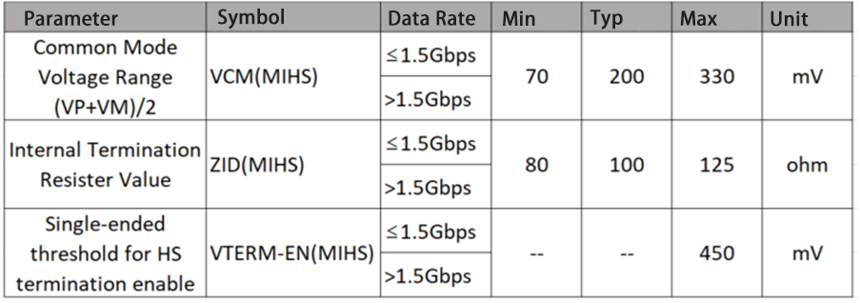

Table 2-14 MIPI D-PHY High Speed (MIHS) Differential AC Electrical Parameters

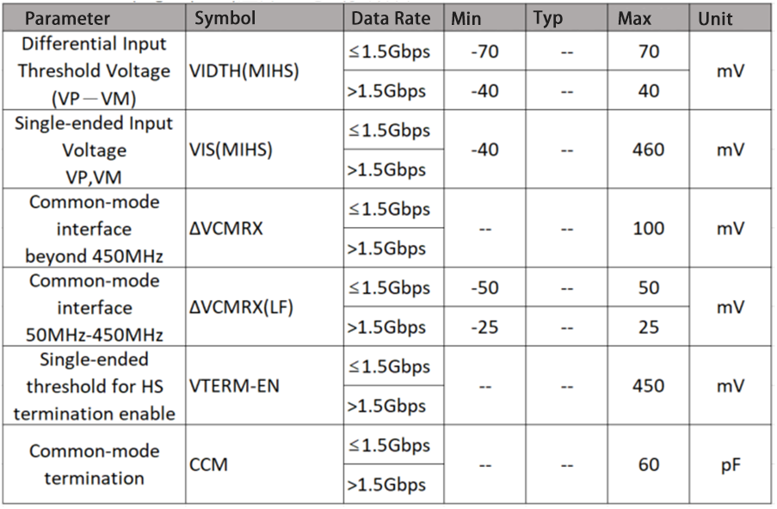

Table 2-15 MIPI D-PHY Low Power (MILP) Differential DC Electrical Parameters

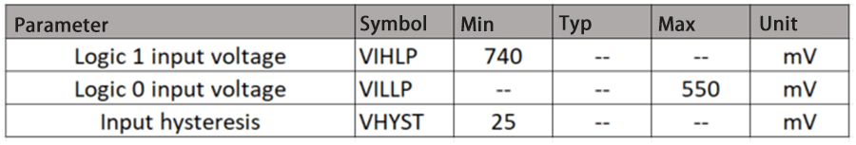

Table 2-16 MIPI D-PHY Low Power (MILP) Differential AC Electrical Parameters

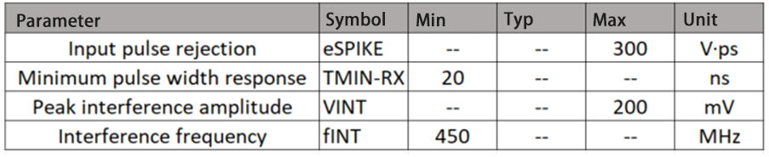

### Sub-LVDS Electrical Parameters

The electrical parameters are shown in Table 2-17 and Table 2-18.

Table 2-17 Sub-LVDS(SL) Differential DC Electrical Parameters

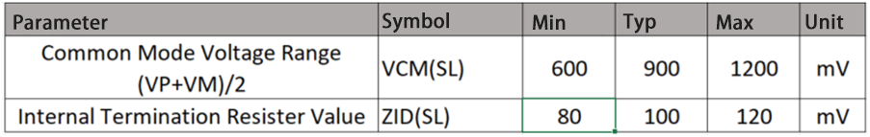

Table 2-18 Sub-LVDS(SL) Differential AC Electrical Parameters

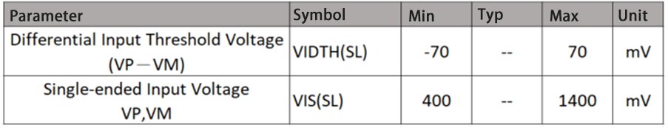

### HiSPi Electrical Parameters

HiSPi is divided into SLVS (HSSL) and HiVCM (HSHI). The electrical parameters are shown in Table 2-19 and Table 2-20.

Table 2-19 HiSPi Differential DC Electrical Parameters

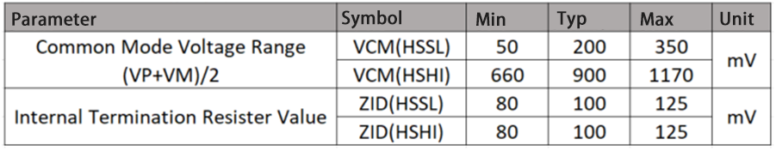

Table 2-20 HiSPi Differential AC Electrical Parameters

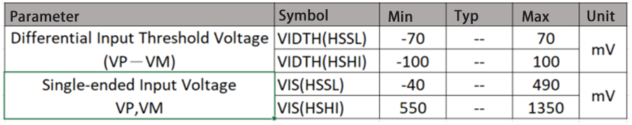

### MIPI /LVDS Tx Electrical Parameters

Table 2-21 MIPI HS Transmitter DC Specifications

|  |  |  |  |  |  |  |
| --- | --- | --- | --- | --- | --- | --- |
| Symbol | Description | Min | Typ | Max | Units | Notes |
| VCMTX | HS transmit static common-mode voltage | 150 | 200 | 250 | mV |  |
| |ΔVCMTX(1,0)| | VCMTX mismatch when output is Differential-1 or Differential-0 | – | – | 5 | mV |  |
| |VOD| | HS transmit differential voltage | 140 | 200 | 270 | mV |  |
| |ΔVOD| | VOD mismatch when output is Differential-1 or Differential-0 | – | – | 14 | mV |  |
| VOHHS | HS output high voltage | – | – | 360 | mV |  |
| ZOS | Single ended output impedance | 40 | 50 | 62.5 | Ω |  |
| ΔZOS | Single ended output impedance mismatch | – | – | 20 | % |  |

Table 2-22 MIPI HS Transmitter AC Specifications

|  |  |  |  |  |  |  |
| --- | --- | --- | --- | --- | --- | --- |
| Parameter | Description | Min | Typ | Max | Units | Notes |
| ΔVCMTX(HF) | Common-level variations above 450MHz | – | – | 15 | mVRMS |  |
| ΔVCMTX(LF) | Common-level variation between 50-450MHz | – | – | 25 | mVPEAK |  |
| tR and tF | 20%-80% rise time and fall time | – | – | 0.3 | UI | 1, 2 |
|  |  | – | – | 0.35 | UI | 1, 3 |
|  |  | 100 | – | – | ps | 4 |

***Note:***

*1. UI is unit interval. Example: 1UI = 1ns for 1Gbps speed.*

*2. Applicable when supporting maximum HS bit rates ≤ 1 Gbps (UI ≥ 1 ns).*

*3. Applicable when supporting maximum HS bit rates > 1 Gbps (UI ≤ 1 ns) but ≤ 1.5 Gbps (UI ≥ 0.667 ns).*

*4. Applicable when supporting maximum HS bit rates ≤ 1.5 Gbps. However, to avoid excessive radiation, bit rates < 1 Gbps (UI ≥ 1 ns), should not use values below 150 ps.*

Table 2-23 MIPI LP Transmitter DC Specifications

|  |  |  |  |  |  |  |
| --- | --- | --- | --- | --- | --- | --- |
| Parameter | Description | Min | Typ | Max | Units | Notes |
| VOH | Thevenin output high level | 1.1 | 1.2 | 1.3 | V | 1 |
|  |  | 0.95 | – | 1.3 | V | 2 |
| VOL | Thevenin output low level | -50 | – | 50 | mV | – |
| ZOLP | Output impedance of LP transmitter | 110 | – | – | Ω |  |

***Note:***

*1. Applicable in normal Low Power mode when the supported data rate ≤ 1.5 Gbps.*

*2. Applicable in normal Low Power mode when the supported data rate > 1.5 Gbps.*

Table 2-24 MIPI LP Transmitter AC Specifications

|  |  |  |  |  |  |  |
| --- | --- | --- | --- | --- | --- | --- |
| Parameter | Description | Min | Typ | Max | Units | Notes |
| TRLP/TFLP | 15%-85% rise time and fall time | – | – | 25 | ns |  |
| TREOT | 30%-85% rise time and fall time | – | – | 35 | ns |  |
| TLP-PULSE-TX | Minimum pulse width | 20 | – | – | ns |  |
| δV/δtSR | Slew rate @ CLOAD = 0 to 70pF (Falling Edge Only) | 30 | – | 300 | mV/ns | 1 |
|  |  | 25 | – | 300 | mV/ns | 2 |
| CLOAD | Load capacitance | 0 | – | 70 | pF |  |

***Note:***

*1. Applicable in normal Low Power mode when the supported data rate ≤ 1.5 Gbps.*

*2. Applicable in normal Low Power mode when the supported data rate > 1.5 Gbps.*

Table 2-25 LVDS Transmitter DC/AC Specifications

|  |  |  |  |  |  |  |
| --- | --- | --- | --- | --- | --- | --- |
| Symbol | Description | Min | Typ | Max | Units | Notes |
| VOS | LVDS common mode offset voltage | 1.125 | 1.25 | 1.375 | V |  |
| |ΔVOS(1,0)| | VOS mismatch when output is Differential-1 or Differential-0 | – |  |  | mV |  |
| VOD | LVDS transmit differential voltage | 247 | 350 | 454 | mV |  |
| |ΔVOD| | VOD mismatch when output is Differential-1 or Differential-0 | – | – | 50 | mV |  |
| TRLP/TFLP | 15%-85% rise time and fall time (DUT side) |  | – | 0.3UI | ns |  |

### SDIO Electrical Parameters

EMMC / SD0 / SD1 Refer to 2.5.7 and 2.5.8

### VI RAW/BT.601/BT.656/BT.1120 Electrical Parameters

Please refer to 2.5.7 and 2.5.8 according to the domain of IO.

### BT.601/BT.656/8080 Electrical Parameters in VO (Video Out)

Please refer to 2.5.7 and 2.5.8 according to the domain of IO.

### AUDIO CODEC Electrical Parameters

Table 2-26 Audio CODEC Overall Indicator Table

|  |  |  |  |  |  |
| --- | --- | --- | --- | --- | --- |
| Parameters | Min | Typ | Max | Unit | Description |
| Analog Power AVDD | 1.62 | 1.8 | 1.98 | V |  |
| VREF |  | 1.4/1.8  *VDD |  | V |  |

Table 2-27 Audio DAC Electrical Parameters

|  |  |  |  |  |  |  |  |  |  |
| --- | --- | --- | --- | --- | --- | --- | --- | --- | --- |
| Parameters | Min | Typ | | Max | | Unit | | Description | |
| Full Output Amplitude | |  | | 1.55 | |  | | Vpp | | Maximum output signal swing |

Table 2-28 Audio ADC Electrical Parameters

|  |  |  |  |  |  |  |  |  |  |
| --- | --- | --- | --- | --- | --- | --- | --- | --- | --- |
| Parameters | | Min | Typ | Max | Unit | | Description | | |
| Maximum Input Amplitude | |  | | 1.75 |  | | Vpp | | Maximum input signal swing |

## Timing

### SPI NOR Timing



Figure 2‑7 SPI NOR Timing Diagram

*IO input timing / IO output timing refers to the IO timing for SPI_NOR CMD/DATA transmission under 1xI/O, 2xI/O, 4xI/O, which includes SPINOR_SDI, SPINOR_SDO, SPINOR_HOLD_X, SPINOR_WP_X.

Table 2-29 SPI_NOR Timing Parameter Table

|  |  |  |  |  |  |  |
| --- | --- | --- | --- | --- | --- | --- |
| Symbol | Description | Min | Gen | Max | Unit | |
| Tcss | Time of CS negative edge to the first clock edge | 13.4 | - | - | ns |
| Tclk | Clock Cycle | 13.4 | - | - | ns |
| Tsu | Input Signal Setup Time Requirements | 3.5 | - | - | ns |
| Thd | Input Signal Hold Time Requirements | 0 | - | - | ns |
| Tov | Output Signal Delay | - | - | 2.6 | ns |
| TOX | Output Signal Hold Time | -1.5 | - | - | ns |

### SPI NAND Timing

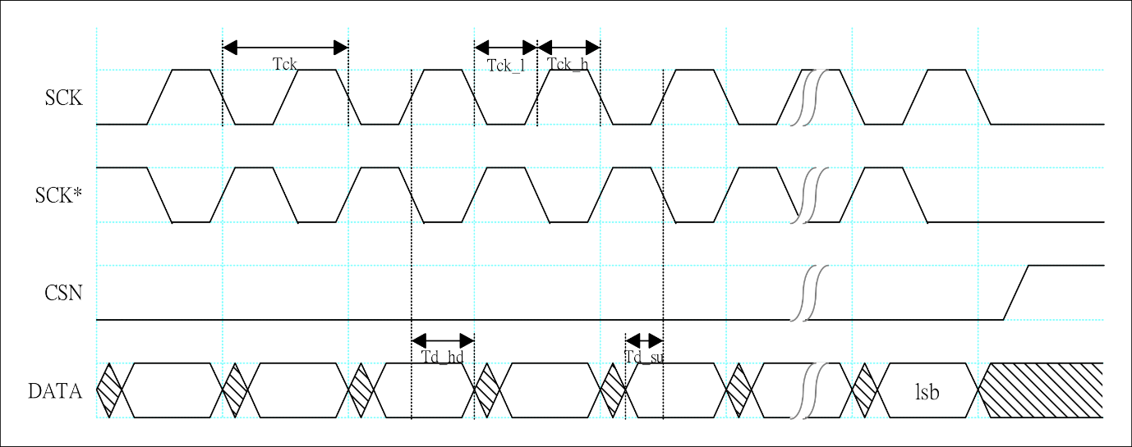

Figure 2‑8 SPI NAND Input Timing Diagram

Table 2-30 SPI NAND Input Timing

|  |  |  |  |  |  |  |
| --- | --- | --- | --- | --- | --- | --- |
| Parameters | Symbol | Min | Typ | Max | Unit | |
| Clock Cycle | Tck | 10.66 |  | 170.56 | ns |
| Input Signal Setup Time Requirements | Td_su | 2.00 |  |  | ns |
| Input Signal Hold Time Requirements | Td_hd | 1.20 |  |  | ns |

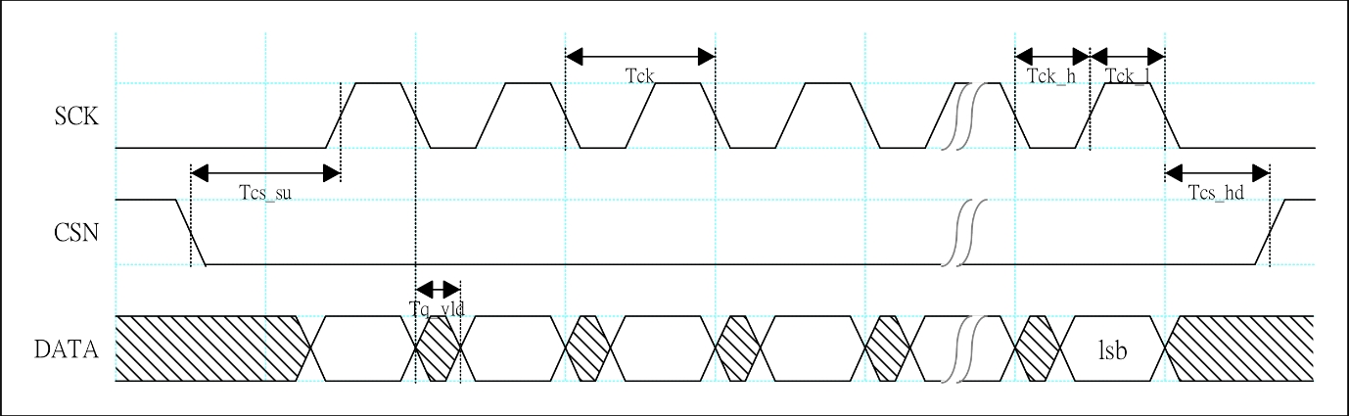

Figure 2‑9 SPI NAND Output Timing Diagram

Table 2-31 SPI NAND Output Timing

|  |  |  |  |  |  |  |
| --- | --- | --- | --- | --- | --- | --- |
| Parameters | Symbol | Min | Typ | Max | Unit | |
| Clock Cycle | Tck | 10.66 |  | 170.56 | ns |
| Clock High Level Period | Tck_h | 5.33 |  | 85.28 | ns |
| Clock Low Level Period | Tck_l | 5.33 |  | 85.28 | ns |
| Output CS Setup time | Tcs_su | 10.66 |  |  | ns |
| Output CS Hold Time | Tcs_hd | 10.66 |  |  | ns |
| Output Signal Delay | Tq_vld | -1.00 |  | 2.00 | ns |

### VI Timing

The VI timing is shown in Figure 2‑10.



Figure 2‑10 VI Timing Diagram

The VI timing parameters are shown in Table 2-32.

Table 2-32 VI Timing Parameter Table

|  |  |  |  |  |  |
| --- | --- | --- | --- | --- | --- |
|  | Symbol | Min | Typ | Max | Unit |
| VICLK clock cycle | T | 6.73 |  |  | ns |
| VIDATA setup time | Tsu | 1.9 |  |  | ns |
| VIDATA hold time | Thd | 0.8 |  |  | ns |

### VO Timing

The VO timing is shown in Figure 2‑11.



Figure 2‑11 VO Timing Diagram

The VO timing parameters are shown in Table 2-33.

Table 2-33 VO Timing Parameter Table

|  |  |  |  |  |  |
| --- | --- | --- | --- | --- | --- |
|  | Symbol | Min | Typ | Max | Unit |
| VOCLK clock cycle | T |  | 6.73 |  | ns |
| VODATA delay time | Tov | T/2-1.5 |  | T/2+1.5 | ns |

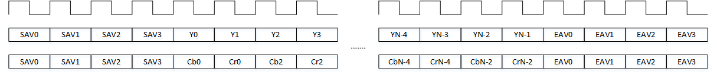

Figure 2‑12 BT.656 Timing Diagram

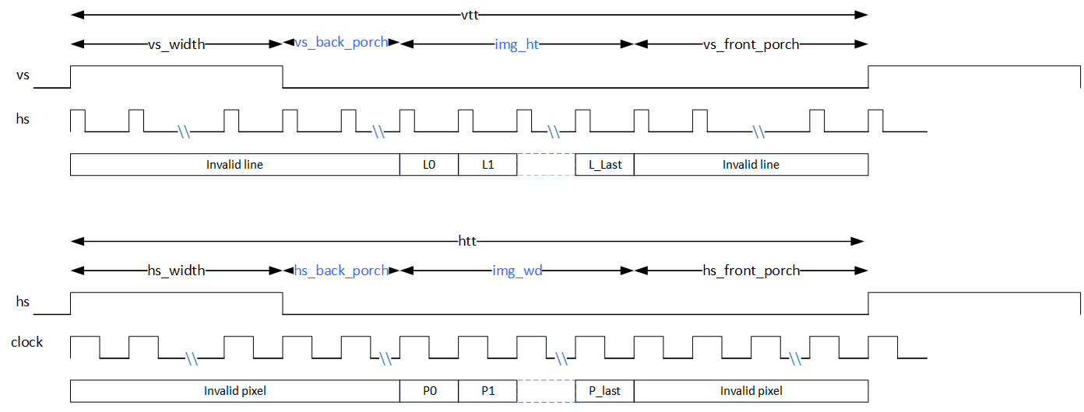

Figure 2‑13 BT.601 Timing Diagram



Figure 2‑14 BT.1120 Timing Diagram

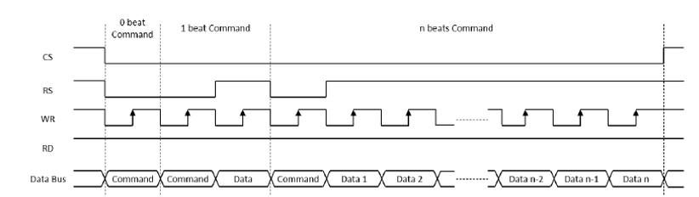

Figure 2‑15 8080 Timing Diagram

### AIAO (I2S/PCM) Timing

The RX timing diagram of I2S and PCM modes for connecting with external Audio Codec is shown in Figure 2‑16.

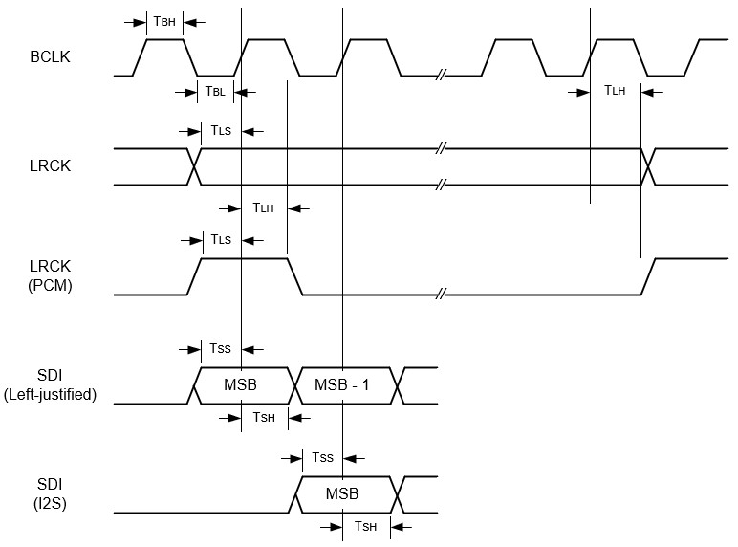

Figure 2‑16 I2S & PCM Rx Timing Diagram

The Tx timing diagram of I2S and PCM modes is shown in Figure 2‑17.

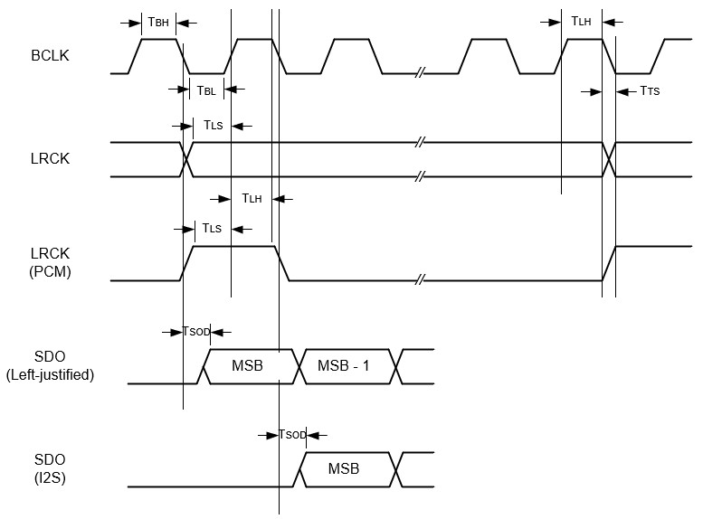

Figure 2‑17 I2S & PCM Tx Timing Diagram

The timing parameters are shown in Table 2-34.

Table 2-34 I2S/PCM Timing Parameter Table

|  |  |  |  |  |  |  |
| --- | --- | --- | --- | --- | --- | --- |
| Symbol | Parameters | Min | Typ | Max | Unit | |
| TBL | BCLK low pulse width (master and slave modes) | 40 | - | - | ns |
| TBH | BCLK high pulse width (master and slave modes) | 40 | - | - | ns |
| TLS | LRCK setup time to BCLK rising (slave mode) | 10 | - | - | ns |
| TLH | LRCK hold time from BCLK rising (slave mode) | 10 | - | - | ns |
| TSS | SDI setup time to BCLK rising (master and slave modes) | 10 | - | - | ns |
| TSH | SDI hold time from BCLK rising (master and slave modes) | 10 | - | - | ns |
| TTS | BCLK falling to LRCK timing skew (master mode) | 0 | - | 10 | ns |
| TSOD | SDO delay time from BCLK falling (master and slave modes) | 0 | - | 10 | ns |

### I2C Timing

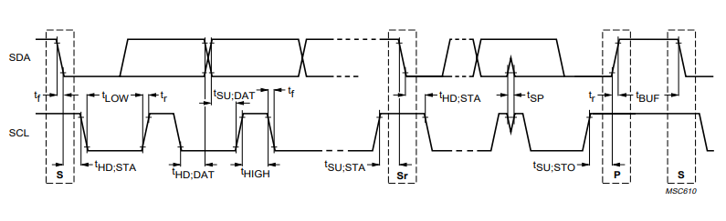

Figure 2‑18 I2C Timing Diagram

Table 2-35 I2C Timing Parameter Table

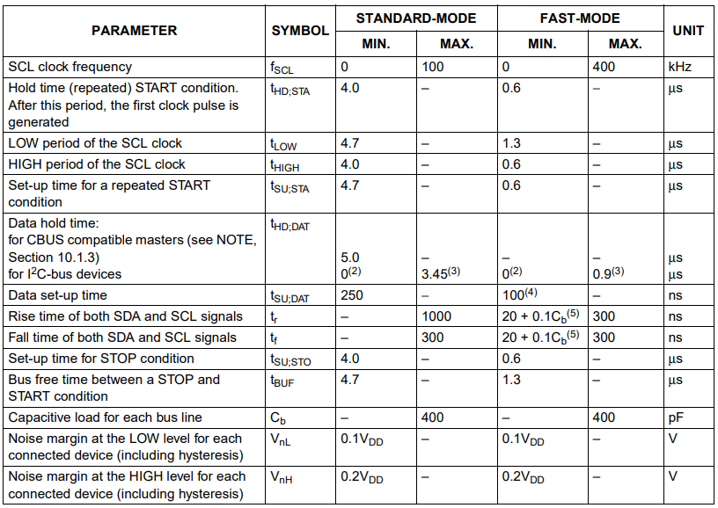

### SPI Timing



Figure 2‑19 SPI Timing Diagram

Table 2-36 SPI Timing Parameter Table

|  |  |  |  |  |  |
| --- | --- | --- | --- | --- | --- |
| Symbol | Parameters | Min | Typ | Max | Unit |
| Fclk | SCK Frequency |  | - | 46.8 | MHz |
| Tcss | Time of CS negative edge to the first clock edge | 21.4 | - | - | ns |
| Tclk | Clock cycle | 21.4 | - | - | ns |
| Tsu | Input Signal Setup Time Requirements | 9.5 | - | - | ns |
| Thd | Input Signal Hold Time Requirements | 0 | - | - | ns |
| Tov | Output Signal delay | - | - | 3 | ns |
| TOX | Output Signal hold time | -3 | - | - | ns |

### MIPI Rx Timing

The speed range of MIPI Rx is: 0.08Gbps ≤ Data Rate ≤ 1.5Gbps

**A.0.08Gbps ≤ Data Rate ≤ 1.5Gbps**

The timing diagram is shown in Figure 2‑20 and the timing parameters are shown in Table 2-37.



Figure 2‑20 Timing Diagram of MIPI Rx Clock when 0.08Gbps ≤ Data Rate ≤ 1.5Gbps

Table 2-37 Timing Parameter of MIPI Rx at 0.08Gbps ≤ Data Rate ≤ 1.5Gbps

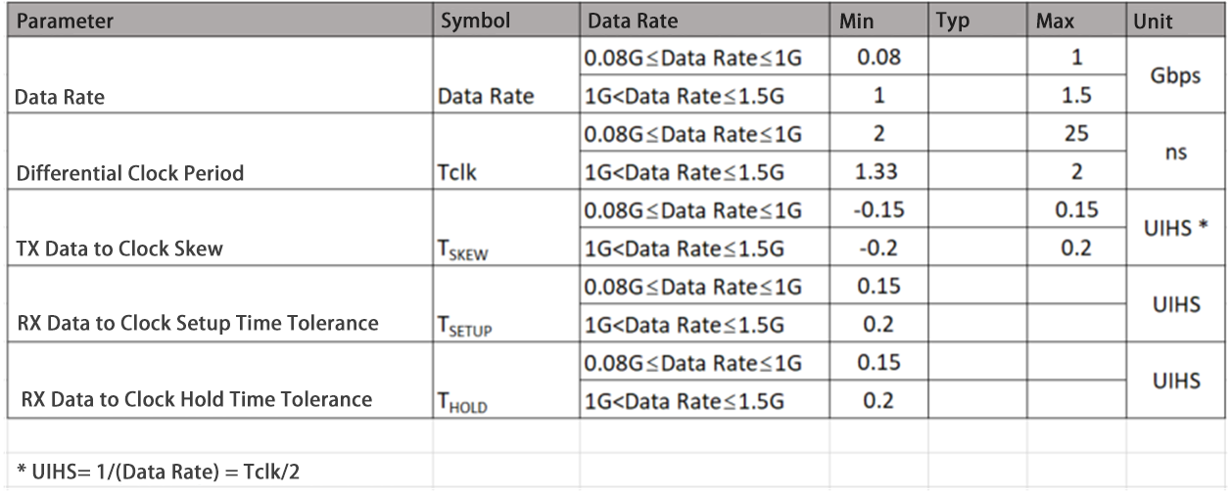

### Sub-LVDS Timing

The Sub-LVDS clock data timing diagram is shown in Figure 2‑21 and the timing parameters are shown in Table 2-38.



Figure 2‑21 Sub-LVDS Clock Data Timing Diagram

Table 2-38 Sub-LVDS Timing Parameter Table

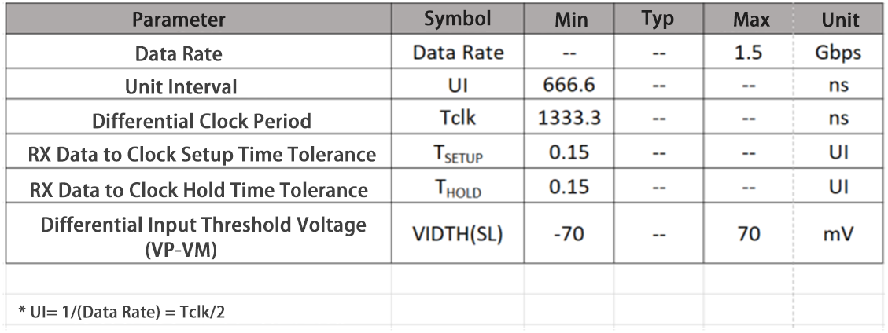

### HiSPi Timing

The HiSPi clock data timing diagram is shown in Figure 2‑22 and the timing parameters are shown in Table 2-39.



Figure 2‑22 HiSPi Clock Data Timing Diagram

Table 2-39 HiSPi Timing Parameters Table

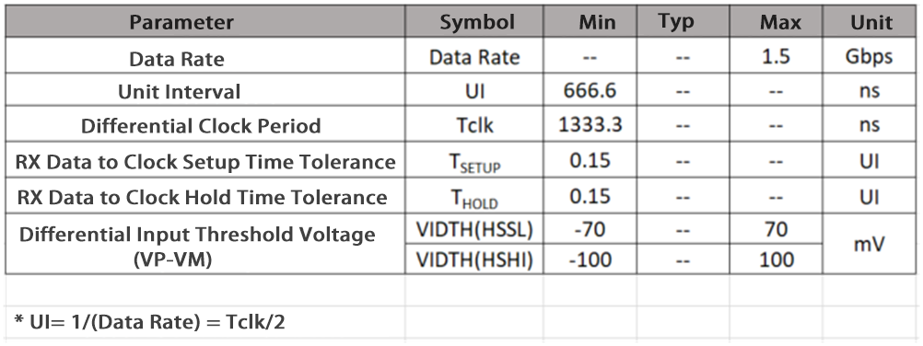

### MIPI Tx Timing

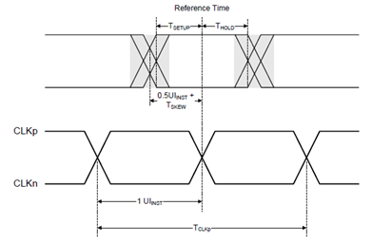

Figure 2‑23 MIPI TX Data-to-Clock Timing Diagram

Table 2-40 Data-Clock Timing Specifications for ≧ 0.08Gbps and ≦ 1 Gbps

|  |  |  |  |  |  |  |
| --- | --- | --- | --- | --- | --- | --- |
| Symbol | Description | Min | Nom | Max | Units | Notes |
| TSKEW[TX] | TX Data to Clock Skew | -0.15 |  | 0.15 | UIHS |  |

Table 2-41 Data-Clock Timing Specifications for > 1Gbps and ≦ 1.5 Gbps

|  |  |  |  |  |  |  |  |
| --- | --- | --- | --- | --- | --- | --- | --- |
| Symbol | Description | Min | Nom | Max | Units | Notes | |
| TSKEW[TX] | TX Data to Clock Skew | -0.2 |  | 0.2 | UIHS |  |

Table 2-42 Data-Clock Timing Specifications for > 1.5Gbps and ≦ 2.5 Gbps

|  |  |  |  |  |  |  |
| --- | --- | --- | --- | --- | --- | --- |
| Symbol | Description | Min | Nom | Max | Units | Notes |
| TSKEW[TX] | TX Data to Clock Skew | -0.2 |  | 0.2 | UIHS |  |
| TJTX | TX Data to Clock Total Jitter |  |  | 0.3 | UIHS |  |
| DJTX | TX Data to Clock Deterministic Jitter |  |  | 0.2 | UIHS |  |
| RJTX | TX Data to Clock Random Jitter |  |  | 0.1 | UIHS |  |

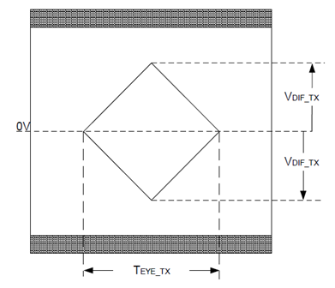

Figure 2‑24 TX EYE Diagram Specification

Table 2-43 Transmitter Eye Diagram Specification

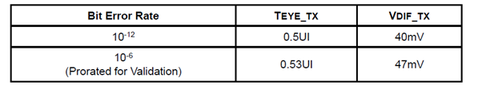

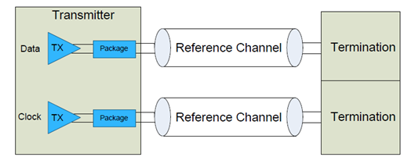

Figure 2‑25 Transmitter Eye Diagram Validation Setup

### SDIO/MMC Timing

The data input/output timing for a single edge is shown in Figure 2‑26.



Figure 2‑26 SDIO/MMC single-edge (SDR) data input/output timing diagram

Table 2-44 SDIO/MMC Single Edge DS (default speed) Mode Timing Parameter Table

|  |  |  |  |  |  |  |
| --- | --- | --- | --- | --- | --- | --- |
| Parameters | Symbol | Min | Typ | Max | Unit | Note |
| Clock CLK | | | | | | |
| Clock frequency Data transfer Mode | fPP | 0 | - | 26 | MHz | fpp=1/tpp  CL≤30pF |
| Clock frequency Identification Mode | fOD | 0 | - | 400 | KHz | CL≤30pF |
| Clock high time | tWH | 10 | - | - | ns | CL≤30pF |
| Clock low time | tWL | 10 | - | - | ns | CL≤30pF |
| Clock rise time | tTLH | - | - | 10 | ns | CL≤30pF |
| Clock fall time | tTHL | - | - | 10 | ns | CL≤30pF |
| Inputs CMD, DAT (referred to CLK) | | | | | | |
| Input set-up time | tISU | 6 | - | - | ns | CL≤30pF |
| Input hold time | tIH | 8.3 | - | - | ns | CL≤30pF |
| Outputs CMD, DAT (referenced to CLK) | | | | | | |
| Output set-up time | tOSU | 5 | - | - | ns | CL≤30pF |
| Output hold time | tOH | 5 | - | - | ns | CL≤30pF |

Table 2-45 SDIO/MMC Single Edge HS (High speed) Mode Timing Parameter Table

|  |  |  |  |  |  |  |
| --- | --- | --- | --- | --- | --- | --- |
| Parameters | Symbol | Min | Typ | Max | Unit | Note |
| Clock CLK | | | | | | |
| Clock frequency Data transfer Mode | fpp | 0 | - | 52 | MHz | fpp=1/tpp  CL≤30pF |
| Clock high time | tWH | 6.5 | - | - | ns | CL≤30pF |
| Clock low time | tWL | 6.5 | - | - | ns | CL≤30pF |
| Clock rise time | tTLH | - | - | 3 | ns | CL≤30pF |
| Clock fall time | tTHL | - | - | 3 | ns | CL≤30pF |
| Inputs CMD, DAT (referred to CLK) | | | | | | |
| Input set-up time | tISU | 6 | - | - | ns | CL≤30pF |
| Input hold time | tIH | 2.5 | - | - | ns | CL≤30pF |
| Outputs CMD, DAT (referenced to CLK) | | | | | | |
| Output set-up time | tOSU | 6 | - | - | ns | CL≤30pF |
| Output hold time | tOH | 3 | - | - | ns | CL≤30pF |

The timing of double edge data input/output is shown in Figure 2‑27.



Figure 2‑27 SDIO/MMC double edge DDR50 mode data input/output timing diagram

Table 2-46 SDIO/MMC Double Edge DDR50 Mode Timing Parameter Table

|  |  |  |  |  |  |  |
| --- | --- | --- | --- | --- | --- | --- |
| Parameters | Symbol | Min | Typ | Max | Unit | Note |
| Clock CLK | | | | | | |
| Clock frequency Data transfer Mode | fP | 0 | - | 52 | MHz | fpp=1/tpp  CL≤30pF |
| Inputs DAT (referenced to CLK) | | | | | | |
| Input delay time during data transfer | tIDLYddr | 1.5 | - | 7 | ns | CL≤20pF |
| Outputs DAT (referenced to CLK) | | | | | | |
| Output set-up time | tOSU | 3 | - | - | ns | CL≤20pF |
| Output hold time | tOH | 2.5 | - | - | ns | CL≤20pF |

The timing diagram of HS200 and SDR104 data input/output is shown in Figure 2‑28 .



Figure 2‑28 SDIO/MMC HS200 and SDR104 mode data command input/output timing diagram

Table 2-47 SDIO/MMC HS200 and SDR104 Mode Output Parameters Table

|  |  |  |  |  |  |  |
| --- | --- | --- | --- | --- | --- | --- |
| Parameters | Symbol | Min | Typ | Max | Unit | Note |
| Output set-up time | tOSU | 1.4 | - | - | ns | CDEVICE≤6pF |
| Output hold time | tOH | 0.8 | - | - | ns |  |

Table 2-48 SDIO/MMC HS200 and SDR104 Mode Input Timing Parameter Table

|  |  |  |  |  |  |  |
| --- | --- | --- | --- | --- | --- | --- |
| Parameters | Symbol | Min | Typ | Max | Unit | Note |
| Phase difference between device TX CMD/DAT and RX CLK | tPH | 0 | - | 2 | UI | Unit Interval (UI) is one-bit nominal time. For 200Mhz, UI=5ns |
| Input valid data window | tVW | 0.575 | - | - | UI | TVW=2.88ns at 200MHz |